CN5006 WEEK-2

1. **Repeat the same process to search education for Master and. Find the avg,min,max age and avg min max Salary of the people group by marital status.**

**Code:**

[

{

'$match': {

'education': 'Master'

}

}, {

'$group': {

'_id': '$maritalstatus',

'average_age': {

'$avg': '$age'

},

'min_age': {

'$min': '$age'

},

'max_age': {

'$max': '$age'

},

'average_salary': {

'$avg': '$salary'

},

'min_salary': {

'$min': '$salary'

},

'max_salary': {

'$max': '$salary'

}

}

}

]

1. **find min,max average salary of each age group of females.**

**Code:**

[

{

'$match': {

'gender': 'Female'

}

}, {

'$group': {

'_id': '$age',

'min_salary': {

'$min': '$salary'

},

'max_salary': {

'$max': '$salary'

},

'average_salary': {

'$avg': '$salary'

}

}

}

]

1. **find min,max average salary of each age group of male**

**Code:**

[

{

'$match': {

'gender': 'Male'

}

}, {

'$group': {

'_id': '$age',

'min_salary': {

'$min': '$salary'

},

'max_salary': {

'$max': '$salary'

},

'average_salary': {

'$avg': '$salary'

}

}

}

]

1. **Count married and unmarried females and males.**

* **For Male**

**Code:**

[

{

'$match': {

'gender': 'Male'

}

}, {

'$group': {

'_id': '$maritalstatus',

'count': {

'$sum': 1

}

}

}

]

* For Female

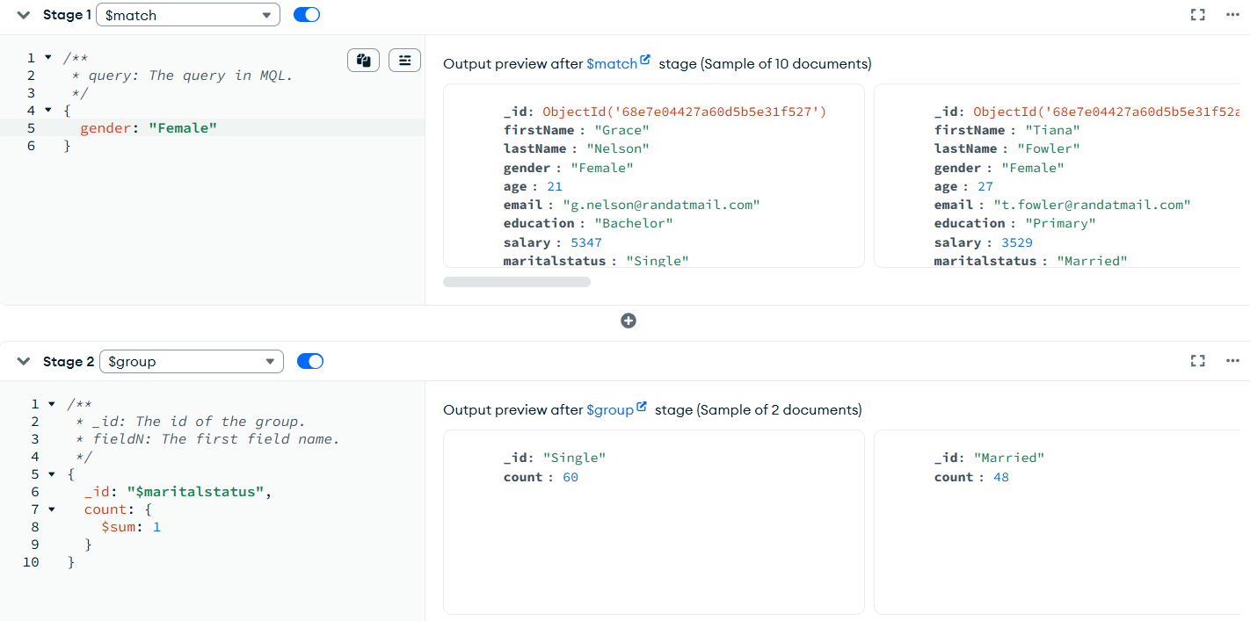

**Code:**

[

{

'$match': {

'gender': 'Female'

}

}, {

'$group': {

'_id': '$maritalstatus',

'count': {

'$sum': 1

}

}

}

]

**Reflection on Week 2 Lab**

This week’s lab focused on mastering the MongoDB Aggregation Framework to extract meaningful statistics from raw data. The core takeaway was understanding how to build an efficient analysis pipeline using a series of stages. First, I learned the importance of filtering data using the $match stage to focus only on relevant subsets, such as people with a 'Master' degree or those of a specific gender. Next, I practiced the central analytical concept: grouping documents using the **$group** stage. This allowed me to segment the population based on fields like age and marital status. Within these groups, I applied aggregation accumulators—specifically **$avg, $min, and $max**—to calculate summary statistics for age and salary. Finally, I learned how to refine the output using **$project** for clarity and **$sort** to order the results, effectively transforming raw data into structured insights about demographic relationships, salary distribution, and employment trends.